Title: Should be Comprehensive, but it is Made as Short as Possible. Subtitle can be given if it needed, Title must be <15 Words
Name of author and co-author, use the superscript for address or institution
¹Address of author
²Address of co-author
E-mail: e-mail of corresponding author
(received ; revised ; accepted )
ABSTRAK (in Bahasa Indonesia)
Name of author and co-author. 2016. Title.
Abstract is the substance of manuscript, written in Indonesian and English, no more than 250 words and stated in one paragraph. Abstract consists of backgound, purpose, material and methode, result and conclution. The author’s name (in CAPITAL form), publication year, manuscript title and journal name are listed before abstract content with layout as reference. Keywords are listed under the abstract, maximum 5 words.
Kata Kunci: Maximum 5 words
ABSTRACT
Name of author and co-author. 2016. Title.
Abstract is the substance of manuscript, written in Indonesian and English, no more than 250 words and stated in one paragraph. Abstract consists of backgound, purpose, material and methode, result and conclution. The author’s name (in CAPITAL form), publication year, manuscript title and journal name are listed before abstract content with layout as reference. Keywords are listed under the abstract, maximum 5 words.
Key Words: Maximum 5 words
INTRODUCTION
Is consisting of research background, issue, efforts which have been made, approach taken to solve the problem and reserach purpose. Use Mendeley Program (http://www.mendeley.com) and citation style of Taylor & Francis - Council of Science Editors (author-date).
MATERIALS AND METHODS
Elucidating clearly about materials used and method carried out.
Subbab
Subsubbab
Table, Figure or Graphic: Table, Figure or Graphic must be clear and explained itself with complete information.

Example for table:
Table 1. The nutritional content of feed PO cattle appropriate physiological status
Physiological status | Nutritional content (DM)
Physiological status | CP (%) | TDN (%) | CF (%)
Dry periode  Mating, pregnant - weaning  Weaning calves - 24 month  Sire candidate (>18 month) and sire | 8-9  9-10  9-10  10-12 | 55-57  57-60  58-60  58-60 | 20-22  18-20  20-22  20-22

DM = Dry matter
CP = Crude protein
TDN = Total digestable nutrient
CF = Crude fiber
RESULTS AND DISCUSSION
It presents and discuss clearly and completely achieved research results based on the purpose. Result and discussion may be presented separated or united. Result description may be completed by consise tables and cleare ilustrations (black and white grafics, figures or photos) on separated page. Tabel description (on top) and ilustration (in bottom) should be clear and independent, so readers may easily understand the table without read the text. Discussion description consists of description of result and research mean and benefit associated with isuue which will be solved. Measurement units both in table or ilustration use metric system. Use Mendeley Program (http://www.mendeley.com) and citation style of Taylor & Francis - Council of Science Editors (author-date).

Example for Figure or Graphic: Should be clear with good resolution (72 pixels/inch or 300 ppi)

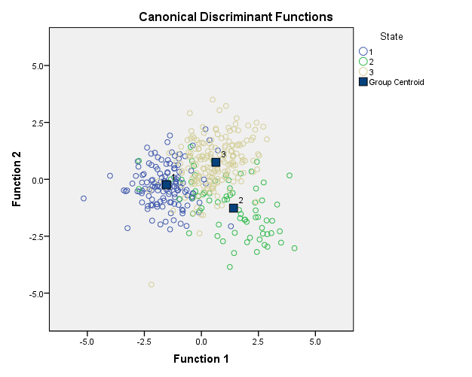
Function 2
Canonical Discriminant Functions
Function 1
Figure 6. Canonical discriminiant functions of three indigenous cows populations (State 1 Tripura 2 Mizoram 3 Manipur)
In Figure or Graphic the text or description must be use Times New Roman with size font 10
Subbab
It presents and discuss clearly and completely achieved research results based on the purpose. Result and discussion may be presented separated or united. Result description may be completed by consise tables and cleare ilustrations (black and white grafics, figures or photos) on separated page. Tabel description (on top) and ilustration (in bottom) should be clear and independent, so readers may easily understand the table without read the text. Discussion description consists of description of result and research mean and benefit associated with isuue which will be solved. Measurement units both in table or ilustration use metric system.
Subsubbab
It presents and discuss clearly and completely achieved research results based on the purpose. Result and discussion may be presented separated or united. Result description may be completed by consise tables and cleare ilustrations (black and white grafics, figures or photos) on separated page. Tabel description (on top) and ilustration (in bottom) should be clear and independent, so readers may easily understand the table without read the text. Discussion description consists of description of result and research mean and benefit associated with isuue which will be solved. Measurement units both in table or ilustration use metric system.
CONCLUSION
It is a manuscript final summary.
ACKNOWLEDGEMENT
It can be written where needed.
REFERENCES
The author shoul use Mendeley Program (http://www.mendeley.com) and citation style of Taylor & Francis - Council of Science Editors (author-date). Mendeley program utilization is aimed to avoid mistakes in citations and references writting. Cited references (preferebly, 80% is primary article and the last 10 years publication). and should not from unpublished articles such as practical guidance and research report, except thesis and dissertation. Download is allowed if it is from electronic magazine, genom database or patent.
Please carefully follow the format of IJAVS.

